Zany Sock Puppets
Santa Clara County Council
You will need:
- Adult-size sock (tube sock works best).
- 8 oz. Yogurt container, large plastic cup, or a section of large cardboard tube.
- Styrofoam ball smaller than the diameter of the container or tube (or you can make a tight ball out of newspaper).
- Dowel or bamboo plant stake (cheaper.)
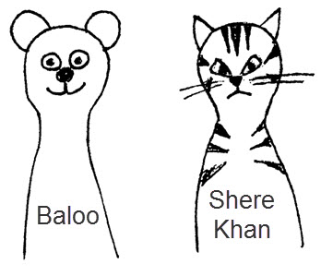
To Assemble the Puppet:
- Make sure the head piece is smaller than the diameter of the container. It needs to go down the container at least part-way with the sock too.
- Glue the dowel or plant stake into the Styrofoam or newspaper ball.
- Stuff the ball into the toe of the sock.
- If using a container or cup, poke a hole in the center of the bottom large enough for the stick.
- Insert the stick through the tube, container or cup.
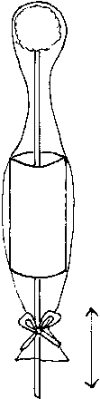
- Pull the sock over the tube/container/cup. Secure the sock below the tube with ribbon or glue.
- Move the stick up and down and have a puppet play.
To Make an Individual puppet:
- Glue specified pieces using illustration as guide.
- You don’t have to use specified pieces.
- Improvisation is encouraged!!
- Make up your own different animals.
- Have fun and make it fun for the boys!!!!
Suggestions:
- Eyes: Wiggle eyes. Felt pieces. Buttons. Rhinestones. Pompom and felt (Frog)
- Nose: Pompoms (pink, black). Felt pieces.
- Ears: Felt pieces, same color for the outer ears, pink for the inner ears.
- Cheeks: Pompoms. Felt pieces.
- Mouth: Rickrack. Felt pieces.
- Collars: Ribbon. Felt pieces. Rickrack. Rhinestones (cat’s collar). Scrap fabric (Tiger).
- Whiskers: Pipe cleaner (inserted through sock face). Rickrack. Thick yarn.
- Antenna: Pipe cleaners glued to the head piece through sock and pompoms.
- Body: Rickrack. Ribbons. Felt pieces.
- Caps: Ankle part of another sock drawn together and a pompom.
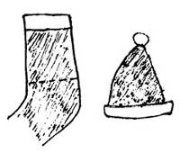
- Straw hat: Store-bought, available at a craft store. Attach ears to the hat (Rabbit).
Newspaper Puppets
Circle Ten Council
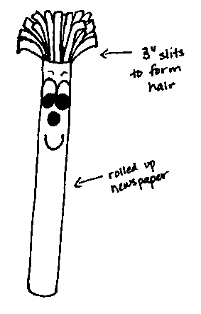
Materials: Newspaper, scotch tape, and white paper
Directions:
- Pile at least five pages of newspaper together.
- Fold them in half (so they are about 11 x 14) and roll them up lengthwise. Make sure that the roll is tight.
- Fold another page in half and wrap it around the roll.
- Tape them all together.
- From the top of the roll, make cuts about three inches long and 1/2 inch apart to make the hair.
- Draw eyes, nose and mouth on the white paper and cut them out. Glue the facial features on the roll just below the hair.

